## Laser Characteristics and Experimental Setup

The first step in creating the driver circuit was to protect the laser diode and fiber from any electrical/static discharges that could potentially damage the semiconductor device from normal handling. A laser diode-specific ESD absorber was chosen for this purpose. The L44-228-X ESD used from LASORB is a 2-pin package with a through-hole mounting style designed for red lasers. There was a preliminary ESD band shorting the pins on the laser and . Once the LASORB was soldered on with the corresponding anode pin to the laser anode, this band was removed. At this time, twisted strand wires were soldered to the pins of the laser. These were chosen over solid wire due to flexibility and integrity issues that solid wire would have after repeated bending.

The next step was to design for operating conditions of the laser as to not damage the equipment. Due to the relatively narrow operating temperature range of 20°C - 30°C, either forced convective or conductive cooling was required. In the case of continuous mode operation of the laser, an effective method would be the use of a thermoelectric peltier cooler running a PID loop. Either positive or negative voltage would then be supplied to control the temperature within the range as desired. Given the nature of the design, however, precise cooling was not required due to the pulsed operation having a maximum pulse width of 100ms. As such, the laser was screw-mounted on a salvaged desktop CPU cooling heatsink with ample thermal paste.

Next to accomplish was the characterization of the current, voltage and power relationships of the laser due to the lack of any given in the associated datasheet.

In this case, the control circuit included a variable power supply at the drain of a power mosfet for testing purposes. The gate was set to 5v for continuous mode operation, as opposed to the pulsed operation arduino/DAC output as the gate control. Figure 123123 is a schematic for the testing of power. A RFP06N30LE power mosfet was used for its ability to handle large currents (30A max) and corresponding power without burning out, as would a typical mosfet.

The laser output was connected to a Newport Model 835 picowatt power meter and the supplied voltages were varied at the gate of the nMOSFET. Given the limitation of the power meter rated maximum at 2W, the characteristics of the laser were taken to 1.95W. Both the currents and voltages were displayed on the power supply, and the voltages across the laser diode was taken by a Fluke 117 electric multimeter, switching to current when necessary. The data was then tabulated (Table 3, appendix) and graphed (graph 3.1,3.2,3.3). Although the power supply was supplying a voltage greater than the max laser operating voltage of 2.2v suggested by the datasheet, the actual voltage dropped across the diode was below 2.2v.

{The operating voltage specified by the datasheet is ≤2.2V. The voltage supplied by the power supply was higher than that. In order to confirm whether this voltage was applied across the diode, measurement across the diode was taken for select current values. The data indicated a voltage drop across the diode was below 2.2v, thus the voltage supplied is dropped across the mosfet the lasorb device

(Confirm this theory and expand on it). }(Figure 1)

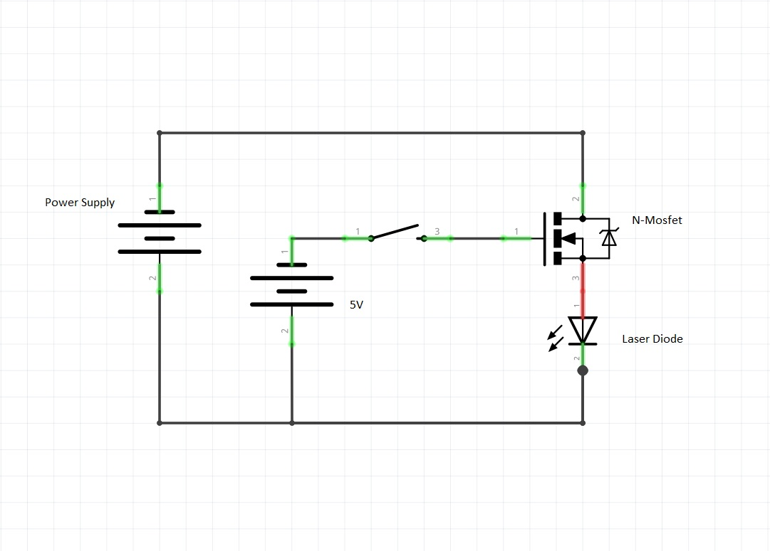

Figure :Schematic diagram of the circuit

Using Ohm’s law, the resistance was found from inverting the slope value of the voltage vs. current graph. As such, the diode laser resistance was found to be suitably low, at around 0.21Ω. The graph of voltage and current also confirms the data sheet listed turn-on threshold being 0.9A. Further extrapolation can be done to predict the power output for higher currents using the linear relationship seen for values above 0.9A.

## MOSFET Driver Circuit Design

The application of this design ultimately calls for usage on skin for either hair removal or skin lesion treatment. As mentioned before, the power output of the laser and subsequent energy absorbed by the skin must thus be accurately controlled using pulse duration and amplitude. Given that the power is directly proportional to current applied after 0.9A, a driver circuit was designed to provide controlled current.

The initial design involved a mosfet based current mirror to provide steady current to a load controlled by the arduino MC/DAC combination found. By changing the gate voltage of a mosfet, the drain current would vary as well in a quadratic relationship as long as the mosfet remained in the saturation region. The first approximation of the drain current in saturation was used to find the expected currents obtained from various gate voltages. In the case of a desired current range of 0A to 5A, the necessary voltage range would be ______.

(Include current mirror schematic)- Voltage range and Equations

(include equations)

For the given design and desired accuracy, the quadratic relationship proved to be an issue. As gate voltage increases, the current and subsequent power is effectively increasing too quickly. The increments of voltage needed to achieve even steps of increased power would then be too small for the DAC resolution (Calculations to be added). As such, the desired operation would use a linearized input voltage vs. drain current relationship.

The current mirror circuit was then dropped and instead, a single supply LM324 opamp chip was used as a comparator in conjunction with the RFP06N30LE power mosfet between the DAC output and mosfet gate. For the inputs, the DAC output was connected to the noninverting input of the op amp with feedback from the source of the mosfet being taken into the inverting input. The output of the op amp was then wired to the mosfet gate. Adding this negative feedback to the comparator controls the output such that the gate voltage has a linear relationship with the current running through the mosfet drain/source. A simulation on spice was done first to see the expected outputs (figure of schem and sim). A 1ohm resistor was also added in series with the laser diode for the negative feedback of the 0v to 5v drop across it corresponding to the 0A to 5A current range. Understanding that the resistor would be ultimately carrying a max of 5A of current and 25W (P=I2R), the resistor should be rated as such. A KAL25FB1R00 chassis mount resistor was used for its 1ohm resistance and 25W power rating in the simulation. Generally, a resistor with a higher power rating would have been chosen, but due to the short pulsed operation, the 25W rating was fine, and one with a higher rating was much more expensive.

(include schematic screencap)

(include simulation screencap)

With the simulations producing the desired output, a test circuit was built with a 3ohm, 25W resistor used for its availability at the time. Another issue arose at this point, with the Agilent E3631A DC power supply being able to only supply a maximum of 1A when using the +25v output (12v was required to power the single supply op amp and the mosfet drain). An older Tektronix PS280 power supply was used in place of the Agilent one, as it was able to supply the current needed when connecting the outputs in parallel internally. Taking the data resulted in a relationship strikingly similar to the simulated ones, with a deviation attributed to the inexact resistance of the 3ohm resistor used. Additionally, the power output was consistent with the current supplied as in table 3.1.

As the voltage was increased at the opamp non-inverting terminal, the mosfet was reaching temperatures up to 75°C. As such, the input voltage was increased until 7.5V with an output current of 2.2A.

(include schematic)

Test Equipment used:

* Newport model 835 picowatt power meter
* Agilent E3631A DC power supply
* Fluke 117 electric multimeter

Parts used:

* Arduino Uno
* MLX90615 temperature sensor
* RFP06N30LE power mosfet
* LM324 opamp
* MCP4725 DAC
* 1ohm 25 watt resistor
* Push button
* LCD screen
* Bluetooth module
* android phone